**DIGITAL MARKETTING**

Assignment1- Creating a blog. Customizing the theme design and posting a new article with 500 words

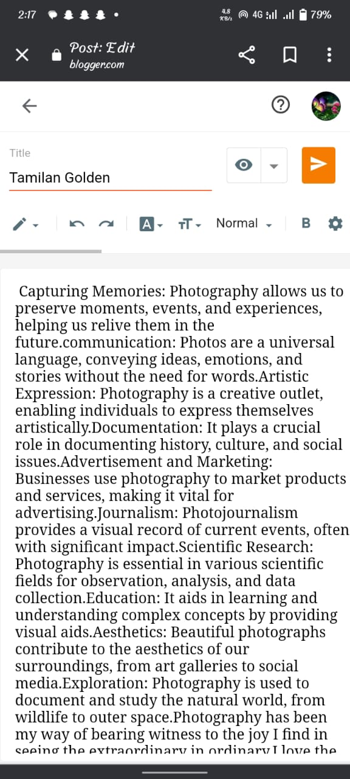

**Blogger post link:**

[**https://www.blogger.com/blog/post/edit/8768711155958161798/2327113793332041752**](https://www.blogger.com/blog/post/edit/8768711155958161798/2327113793332041752)

**passage:**

**PHOTOGRAPHY**

**Explore The World**

Capturing Memories: Photography allows us to preserve moments, events, and experiences, helping us relive them in the future. Journalism and Storytelling: Photojournalism and documentary photography play a crucial role in conveying news, stories, and social issues, often creating profound impacts. Scientific Research: Photography is essential in scientific research for visual data collection, analysis, and documentation in fields such as astronomy, biology, and archaeology. Education and Learning: Visual aids and photographs enhance the learning experience, simplifying complex concepts and making education more engaging. Aesthetics and Beauty: Photography contributes to the aesthetics of our world, from fine art photography displayed in galleries to the everyday beauty captured on social media. Communication: Photos are a universal language, conveying ideas, emotions, and stories without the need for words. Artistic Expression: Photography is a creative outlet, enabling individuals to express themselves artistically. Documentation: It plays a crucial role in documenting history, culture, and social issues. Advertisement and Marketing: Businesses use photography to market products and services, making it vital for advertising. Photography has been my way of bearing witness to the joy I find in seeing the extraordinary in ordinary. I love the people I photograph. I mean, they’re my friends. I’ve never met most of them or I don’t know them at all, yet through the image, I live with them. Most things in life are moments of pleasure and a lifetime of embarrassment; photography is a moment of embarrassment and a lifetime of pleasure. The golden rule in the arts, as far as I am concerned, is that all rules are meant to be broken.